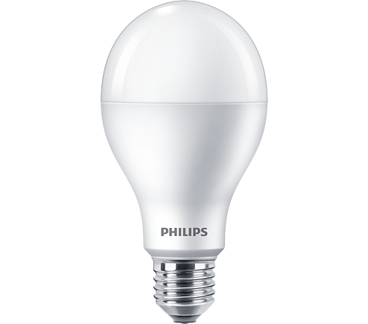

LED BULB

* 6.5W-45(GLS 45, CLFi 10)W
* E14
* White

Rs.280